INVITATION | 

The 4th China Zhengzhou International Abrasives & Grinding Exposition
DATE: 14th~16th SEP., 2017
VENUES: Zhengzhou International Convention and Exposition Centre, Henan, China

★Approver: Ministry of Commerce of the People’s Republic of China
★Supporters: China National Machinery Industry Corporation
Superhard Materials Industrial Technology Innovation Strategy Alliance
★Organizers: The People’s Government of Zhengzhou
China National Automotive Industry International Corporation
SINOMACH Precision Industry Co., Ltd.
★Sponsors: Industrial Diamond Association of China Abrasives Association of China
Coated Abrasives Association of China SINOMACH Exhibition Co., Ltd.
★Co-sponsors: Industrial Diamond Association of America
The National Center of Superhard Materials & Tools Engineering Research
The National Center of Abrasives & Grinding Tools QC Supervision and Inspection
National Technical Committee on Abrasives & Grinding Standardization
China Metal Cutting Tool Engineering Association China Abrasives Information Network .
Henan Refractory Materials Association, Henan University of Technology, IAbrasive, et

TECHNOLOGY LEADS FUSION & SHARE

Exposition Overview

China (Zhengzhou) International Abrasives & Grinding Exposition (A&G Expo) is recognized as the only international grinding technology exposition with globally renowned popularity, featuring abrasives and abrasives products, superhard materials and products. A&G Expo provides solutions for abrasive & grinding with the latest technologies and products covering the entire industry chain.

The 3rd A&G Expo attracted 315 exhibitors from nine countries and the exhibit area was 20,000 square meters, with approximately ten thousand professional visitors from twenty-four countries and regions all over the world. During the period, eight major series of activities and nearly one hundred reports were held.

The 3rd A&G EXPO Recap 1. Distinctive Features of the EXPO Attracted Visitors from Manufacturing Industry

Abrasives and abrasives products are known as “industrial teeth”. Consistent innovation in superhard materials technology has accelerated expansion of application fields. Intelligent machine tools like grinding and cutting equipment have pushed the manufacturing industry to step closer to “Made with Wisdom”. The A&G Expo has converged industrial powerful tools to attract practitioners of the manufacturing industry coming for a visit. 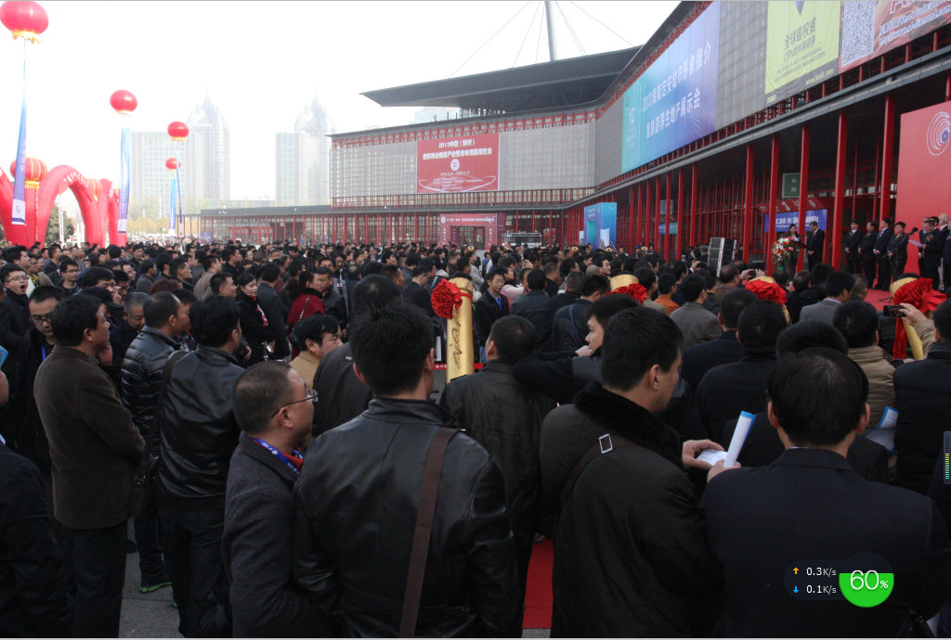

2. The Opportunity to Cooperate with China Attracted Global Attention

Visitors came from twenty-four countries and regions, covering Asia, Europe, and America. Among them more than 81% visitors were from Asia, in which Chinese ranked top, followed by Indian, Japanese and Korean.
China’s emerging economy has provided cooperation opportunities for exhibitors.
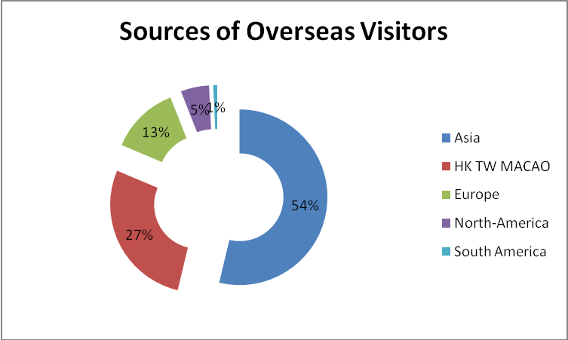

3. Superior Buyers to Bring unlimited opportunities

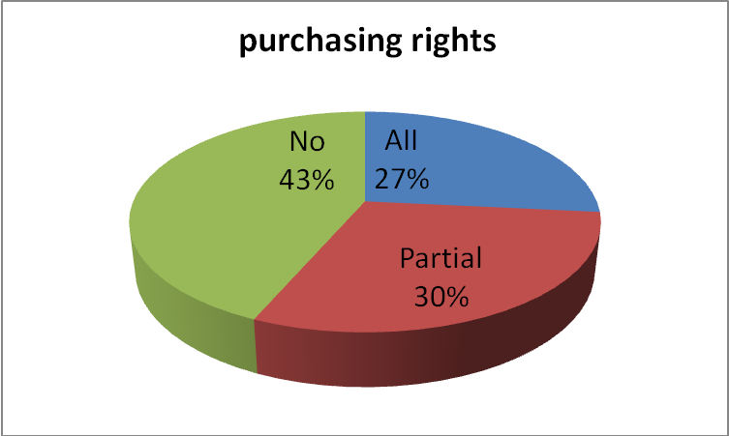
Visitors that had purchase decision making rights (27%) and partial purchasing rights (30%) were in the majority. Superior buyers signed purchasing agreements frequently on site.

4. Satisfied Exhibitors Insist on the Next Expo. More than 97% exhibitors expressed satisfaction towards comprehensive effect and service of the Expo and 98% exhibitors were considering attending the next EXPO.
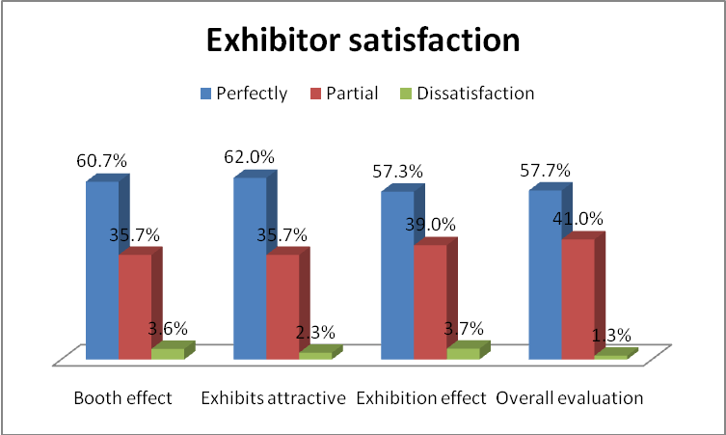

5. Participants’ Recognition Testified Professional Brand of A&G EXPO
The exhibits were "Famous, distinctive, superior, latest, and professional", and the expo was well organized and highly efficient, providing a high-quality platform where participants could establish business relationships and communicate with one another. The abrasives industry spoke highly of A&G expo that built up its professional brand.

6. Remarks from Exhibitors
“Large-scale expo of the abrasives industry”
“Professional with good popularity”
“A professional industry exhibition is essential for industry communication.”
“It’s terrific in scale and service.”

II. Exhibits Range
1. Abrasives Products and Auxiliary Materials
(1) Superhard Materials and Related Products: synthetic diamond, cubic boron nitrid and micro powder, PDC, PCD, PCBN, CVD diamond and various kinds of related products for cutting, drilling, grinding and polishing, etc.
(2) Conventional Abrasives and Related Products: fused alumina, silicon carbide, boron carbide, bonded abrasives, refractory materials, etc.
(3) Coated Abrasives: sanding belts, sanding discs, sanding sheets and various kinds of abnormal-shaped coated abrasives, etc.
(4) Auxiliary Materials: raw materials, molds, all kinds of binders, metal powder, adhesives, matrix, etc.

2. Various kinds of special equipment and detecting instruments for abrasives & grinding
Synthetic diamond press machine, sorting machine, screening machine, magnetic separator, shaking table, mixing machine, forming machine, hot press, cold press machine, sintering furnace, welding machine, laser cutting machine, corundum and silicon carbide furnaces, crushing and milling machines, firing and hardened equipment, grinding wheel processing equipment, emery cloth manufacturing equipment and all kinds of testing equipment and instruments for abrasives & grinding, etc.

3. Related Equipment and Tools for Abrasives & Grinding
Grinding machine, grinding center, electro processing equipment, lapping machine, polishing machine, honing machine, grinding robot and all kinds of accessories and related auxiliary materials and products, etc.; Metal forming machine tools, metal cutting and welding equipment, CNC system and functional components, industrial automation, machine tool accessories and components; All kinds of tools, cutting tools, measuring tools, etc.

4. Related Institutions for Abrasives & Grinding
Relevant scientific research, colleges and universities, media, industry associations, detection institutions and industry bases and so on.

III. Price 1.Booth
Package stand indoor (3m×3m) | Bare stand indoor ≥36m2
USD1700/9㎡ | USD170/㎡
PS: 1. The area of package stand indoor: an integer multiple of 3 and ≥9㎡e.g. 9, 12…, the area of the package stand with two openings: ≥18㎡；
2.The fee of the package stand：USD570/3㎡；the package stand with two openings: 10% extra payment.
3. There will be 5% discount if the fee of stand is paid before 30/06/2017.
2. Product Promotion
$1000 /50minutes | Organizer provides: lighting, desk, chair, water, audio, projector, etc.
3. Advertisement on Catalogue
Front cover | Back cover | Inside front cover | Inside back cover | Influential page | Ordinary color page | B&W logo & 2D barcode
$3300 | $2500 | $2100 | $2000 | $2000 | $500 | $100
4. On-site Ads
Show ways | Position | Specifications (W×H) | Price
Picture | 1st floor pillar | 3 m×6m | $500
Picture | 2nd floor2 | 10m×10m | $2500
Picture | Corridor | L×1.1m | $15/㎡
Picture | Pillar in hall | 2m×8m | $300
Picture | Billboard indoor | 5.0m×2.5m | $800
Picture | Billboard outdoor | 10m×4m | $800
Arch balloon | Square outdoor | Span 20m | $800
Inflatable pillar | Square outdoor | Height10m | $500
Helium balloon | Square outdoor | Diameter 2.5m | $800

IV. Offices of the Organizing Committee

SINOMACH Exhibition Co., Ltd.
Tel: +8610-88493319 88496382
FAX: +8610-88496683
Email: panxiaoyu@cnaico.com.cn
Contacts: Mr Pan, Ms Wang

Industrial Diamond Association of ChinaTel: +86371-67658993 67661785
FAX: +86371-67657827
Email: szd_841023@163.com
Contacts: Mr Sun, Mr Zhao, MS Zhao
Abrasives Association of China
Tel: +86371-67630668/67680711
FAX: +86371-67636838
Email: caaorg@china.com
Contacts: Ms Feng, Ms Xia, Mr Zhou

Coated Abrasives Association of China
Tel: +86371-67661302 67657825
FAX: +86371-67661302
Email: zgtfmj@163.com
Contacts: Ms Zhao, Mr Che

